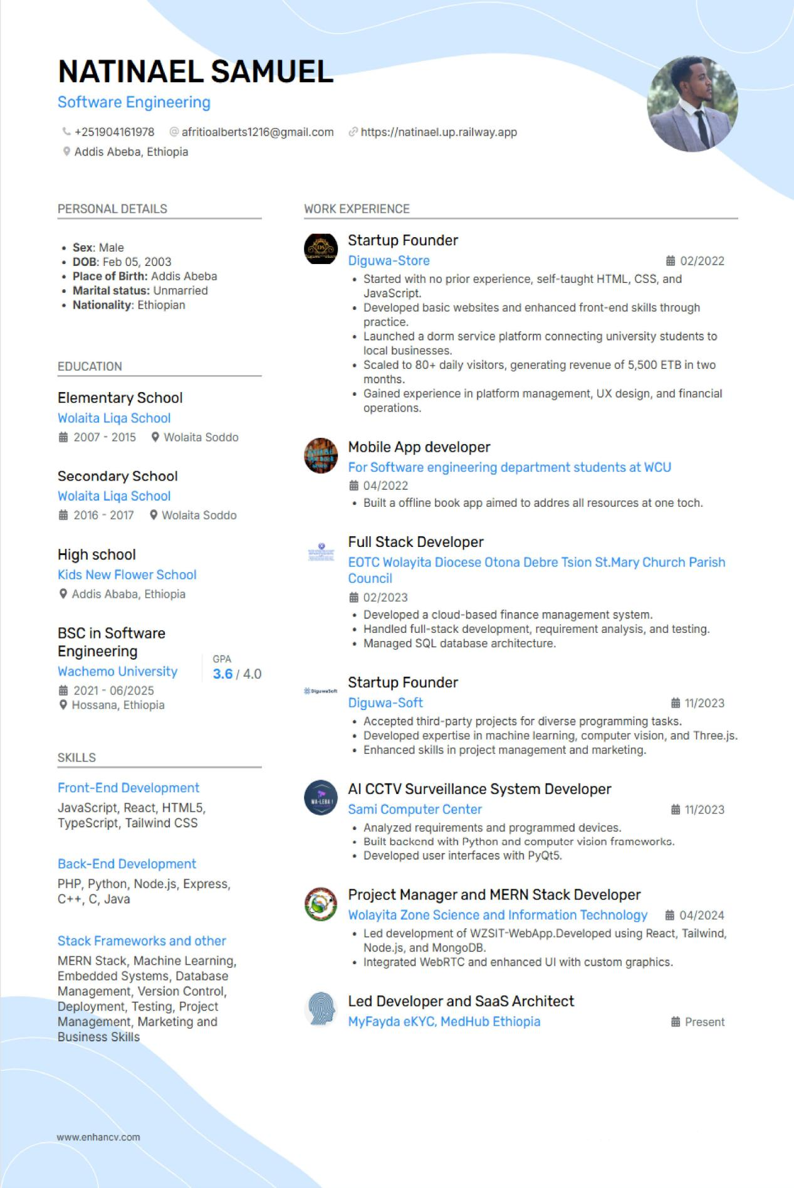

**I would like to share the story behind the projects I have built  the problems I faced, my approach, and the lessons I learned.**

**Natinael Samuel**  
BSc, Software Engineering  
+251 904 161 978  
afritioalberts1216@gmail.com  
[Portfolio](https://natinael.up.railway.app) : <https://natinael.up.railway.app>

**1. Diguwa-Store (Startup Project)**

**Problem**: Students in my dorm were not only lacking in supplies because of destance from university to city but also it was a headache for the students to get the things they wanted in terms of study materials.  
  
**Approach**: I had no previous experience so I started from scratch with self taught HTML, CSS, and JavaScript and on top of that, I came up with a service platform. I made use of simple UX and continuous iteration based on the feedback of the users.  
  
**Lesson**: The software scenerio portrayed through this incident showed how software can be the direct bridge to the community needs and also taught me entrepreneurship which was shown through the scaling to 80+ daily users and the revenue generated.  
  
**2. St. Mary Finance Management System**

**Problem**: Parish finance was carried out through normal paper works, which made the whole process slow and prone to errors.  
  
**Approach**: I interacted with the finance head to get the requirements then I did the SQL database schema design. Later, I coded a PHP/JS web app with live reporting.  
  
**Lesson**: I cooperate with all parties involved in the project, and design scalable database backed systems.  
  
**3. Wolayita Zone Science & IT WebApp**

**Problem**: The regional office has no efficient or quick way to deliver tech support to the different remote areas.  
  
**Approach**: I developed a MERN stack app with WebRTC for live video calls and TailwindCSS for the UI. The whole process was done by me and my small team.  
  
**Lesson**: The entire process taught me deep leadership, the teamwork of my crew, and the limitations of implementing real time communication functionalities at large scale.

**4. Wa-Leba AI SaaS Security System**

**Problem**: The small businesses didn’t have the surveillance tools that were affordable and intelligent enough to alert them.  
  
**Approach**: I combined the power of computer vision (YOLO, LRCN, ConvLSTM) with a React/Node.js platform that is compatible with ONVIF and RTSP camera protocols.  
  
**Lesson**: I learned how to architect for scalability, to rework ML pipelines efficiently, and to take into account various scenarios of network latency and resource restrictions.

**5. MyFayda eKYC (National ID Integration)**

**Problem**: The digital economy in Ethiopia was in dire need of a reliable identity verification system.

**Approach**: I constructed a publicly-available source MERN-stack OAuth/eKYC platform that interfaces with the Fayda National ID. The key aspects of the platform were security, encryption, and trust.

**Lesson**: The creation of MyFayda eKYC allowed me to enhance my knowledge of authentication, authorization as well as secure digital identity systems.

**6. MedHub Ethiopia (Electronic Medical Record)**

**Problem**: The medical personnel had a hard time dealing with patient records that were fragmented and inefficient.

**Approach**: I managed the design and development of the first-ever EMR in Ethiopia, taking it a step further by fusing it with the National ID system. We utilized MERN stack and WebRTC for the doctor-patient communication.

**Lesson**: I was exposed to designing of systems for vital services, the significance of the system being dependable, and methods of matching technical systems with off-workflows.

**7. Trivia Game & Offline Bookstore App (Community-focused projects**)

**Problem**: The digital engagement was limited in a local Sunday school and the students had restricted internet access.

**Approach**: I developed a PyQt5 based trivia game that is played on one shared computer and also an offline Android book application for students was created so that they could have access to the study materials even when there was no internet.

**Lesson**: The above projects immensely contributed to my skills of working under limitations and also in coming up with easy, feasible solutions that have a significant impact.